Test Campaign Report Template
==============================================================
Campaign Report [Product] [Campaign Type] [Date]
______________________________________________________________________
[GO – NO GO]
______________________________________________________________________
Objectives
- Verify site compliance with specifications: ensure the website meets the specifications defined in the requirements.
- Validate website functionality: ensure the site operates correctly and meets user expectations.
- Identify and correct anomalies: pinpoint problems and anomalies on the website so they can be fixed before production release.
- Test the minimum to cover the maximum requirements by grouping requirements.
- No critical anomalies.
______________________________________________________________________
Key Results – Summary

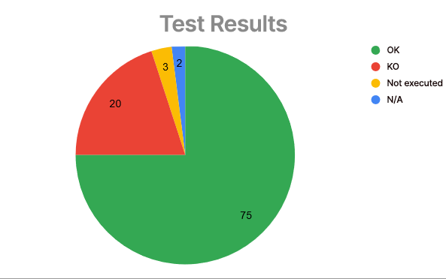
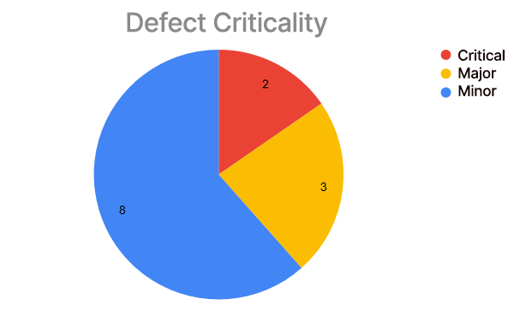
Failing functionalities: [list of functionalities with at least 1 bug]
Main bugs: [List of critical and major bugs: ID and title]
______________________________________________________________________
Full Results
[Results by functionality]
[All bugs]
==============================================================

